Before getting started the website we needed to test the website in many cases and the whole website design testing tools is bellow and I have explain all the testing sections part by part for the website design for this website. I’ll use the following toolkit to complete the testing process:

1. **Website Speed:** We use <https://gtmetrix.com> for website speed test. Report’s are mentioned bellow:

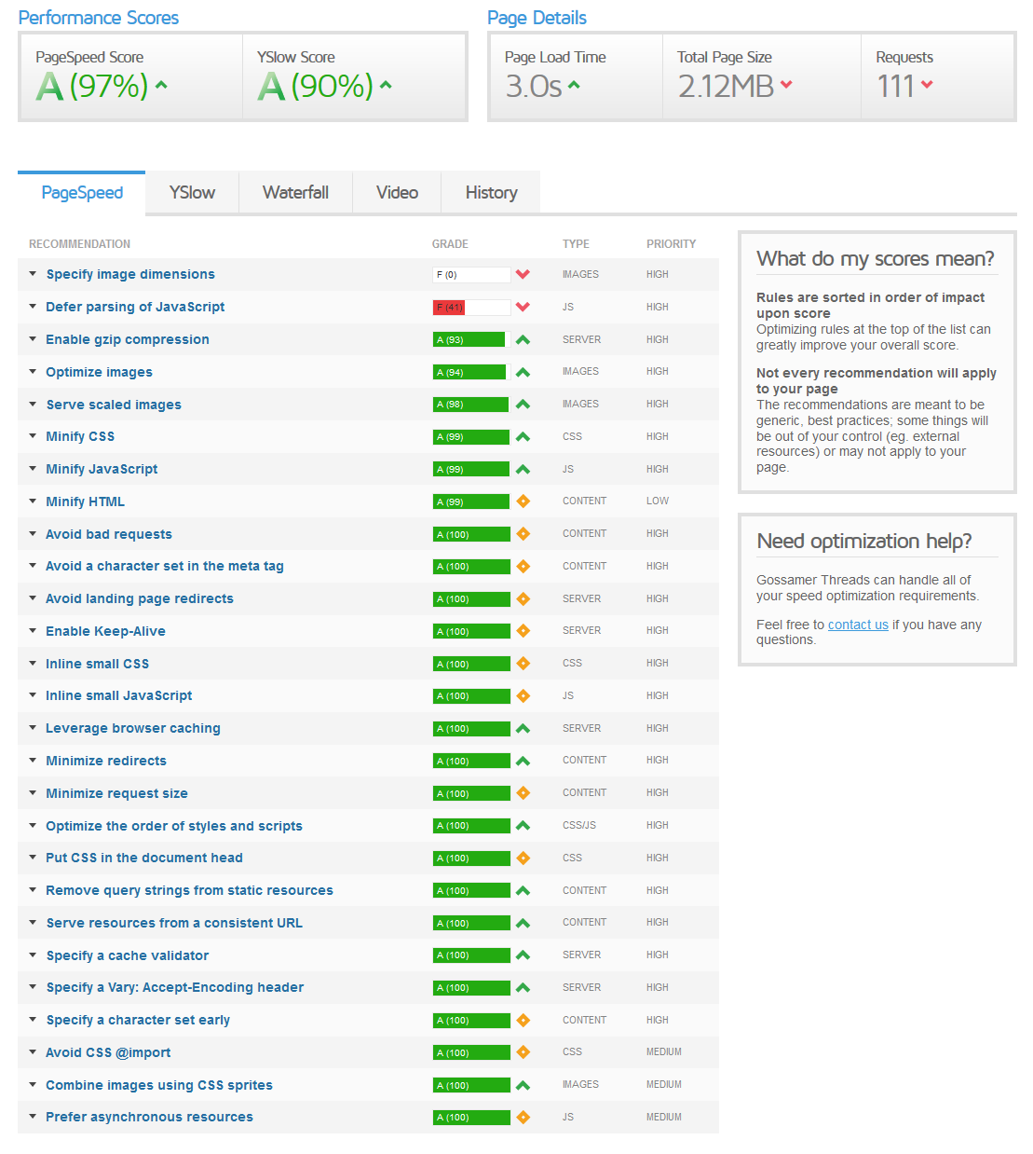

1. **IDEs:** IDE stands for “Integrated Development Environment.” These usually consist of at least a source code editor, build automation tools, and a debugger. I use sublime text and nodepad ++.
2. [**XAMPP**](https://www.apachefriends.org/download.html): The AMPP part of XAMPP stands for “Apache, MySQL, PHP, Perl.” The application lets you create an offline server on your computer for development outside of a live site. No need to be connected to the Internet. Alternatives are [WampServer](http://www.wampserver.com/en/" \o "WampServer - Offline development environment" \t "_blank) (for Windows) and [MAMP](https://www.mamp.info/en/) for Mac. I use XAMPP.
3. **Wp code generator** : I use code generator for custom query , post type, taxonomy etc.